WEEK 3 INTERNSHIP REPORT
Statistical Analysis and Predictive Modeling using R
Spotify Most Streamed Songs 2025 Dataset

Intern | Bala Gayatri
Internship | YuvaIntern – NSDC
Week | Week 3
Technology | R / RStudio (Posit Cloud)
Dataset | Most Streamed Spotify Songs 2025

- Executive Summary
This report presents the statistical analysis and predictive modeling performed during Week 3 of the internship using R. The analysis continued with the Most Streamed Spotify Songs 2025 dataset that was previously cleaned and preprocessed during Week 1. Using the prepared dataset allowed the analysis to focus specifically on statistical relationships, hypothesis testing, predictive modeling, model evaluation, and diagnostic analysis.The analysis began with exploratory statistical examination of the prepared dataset using functions such as head(), str(), and summary(). The relationship between daily streaming activity and total Spotify streams was then examined using correlation analysis and Pearson's correlation hypothesis test. Normality testing was also performed to assess the distributional characteristics of the variables used in the analysis.For predictive modeling, the dataset was divided into training and testing subsets using an 80:20 split. A multiple linear regression model was developed to predict total Spotify streams using daily streams and daily stream share percentage as explanatory variables. Predictions were generated for the testing dataset and evaluated using Mean Absolute Error (MAE), Root Mean Squared Error (RMSE), and R-squared. Five-fold cross-validation was additionally performed to assess the stability of the regression model. Finally, diagnostic plots and an actual-versus-predicted plot were generated to evaluate model assumptions and prediction performance.The analysis demonstrates the application of statistical reasoning and predictive modeling techniques to a real-world music-streaming dataset.

2.Table of Contents
1. Executive Summary  2. Table of Contents  3. Screenshot Checklist  4. Objectives  5. Dataset Overview  6. Exploratory Statistical Analysis  7. Correlation Analysis  8. Hypothesis Testing  9. Normality Testing  10. Train-Test Split  11. Predictive Model Building  12. Model Prediction  13. Model Performance Evaluation | 14. Cross-Validation  15. Diagnostic Analysis  16. Actual vs Predicted Values  17. Model Strengths and Potential Improvements  18. Key Findings  19. R Code Appendix  20.Conclusion

3.ScreenShot Checklist
S. No. | Screenshot / Evidence | Section
1 | First few rows of the cleaned Spotify dataset | Dataset Overview
2 | str(spotify) output | Exploratory Statistical Analysis
3 | summary(spotify) output | Exploratory Statistical Analysis
4 | Correlation coefficient output | Correlation Analysis
5 | Pearson correlation test output | Hypothesis Testing
6 | Shapiro-Wilk normality test outputs | Normality Testing
7 | Training and testing dataset sizes | Train-Test Split
8 | Regression model summary(model) output | Model Building
9 | Predicted values output | Model Prediction
10 | MAE, RMSE and R² results | Model Evaluation
11 | Five-fold cross-validation output | Cross-Validation
12 | Four regression diagnostic plots | Diagnostic Analysis
13 | Actual vs Predicted plot | Model Evaluation

4. Objectives
The main objectives of this week's task were:
- To perform exploratory statistical analysis on the prepared Spotify dataset.
- To investigate the relationship between daily streams and total Spotify streams.
- To formulate and test a statistical hypothesis using Pearson's correlation test.
- To examine the normality of the variables used in the analysis.
- To develop a predictive regression model using R.
- To divide the dataset into training and testing subsets.
- To evaluate the predictive model using MAE, RMSE, and R-squared.
- To apply five-fold cross-validation to assess model stability.
- To perform regression diagnostic analysis.
- To compare actual and predicted values visually.
- To identify potential strengths and limitations of the developed model.

5. Dataset Overview
Dataset Used
Dataset: Most Streamed Spotify Songs 2025
The dataset contains information related to songs and their Spotify streaming performance. It was selected because it contains numerical variables suitable for statistical analysis and predictive modeling.
The Week 1 cleaned and preprocessed version of the dataset was used as the starting point for this analysis. This allowed the Week 3 task to focus on statistical analysis and predictive modeling without repeating the data-cleaning process already completed previously.
Variable | Description | Role
daily_streams | Daily streaming activity | Predictor
spotify_streams_total | Total Spotify streams | Target variable
daily_stream_share_pct | Daily stream share percentage | Predictor

6. Exploratory Statistical Analysis
6.1 Dataset Inspection
The first few records were inspected using:
head(spotify)
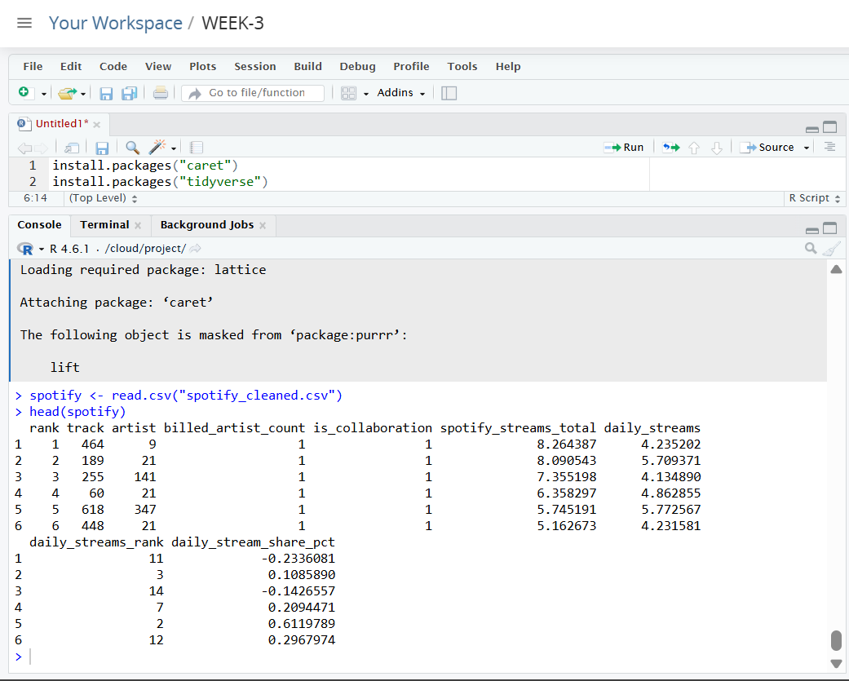
Figure 1. First records of the cleaned Spotify dataset
The output confirmed that the cleaned dataset was successfully imported into Posit Cloud and was available for further statistical analysis.
6.2 Dataset Structure
The structure of the dataset was examined using:
str(spotify)
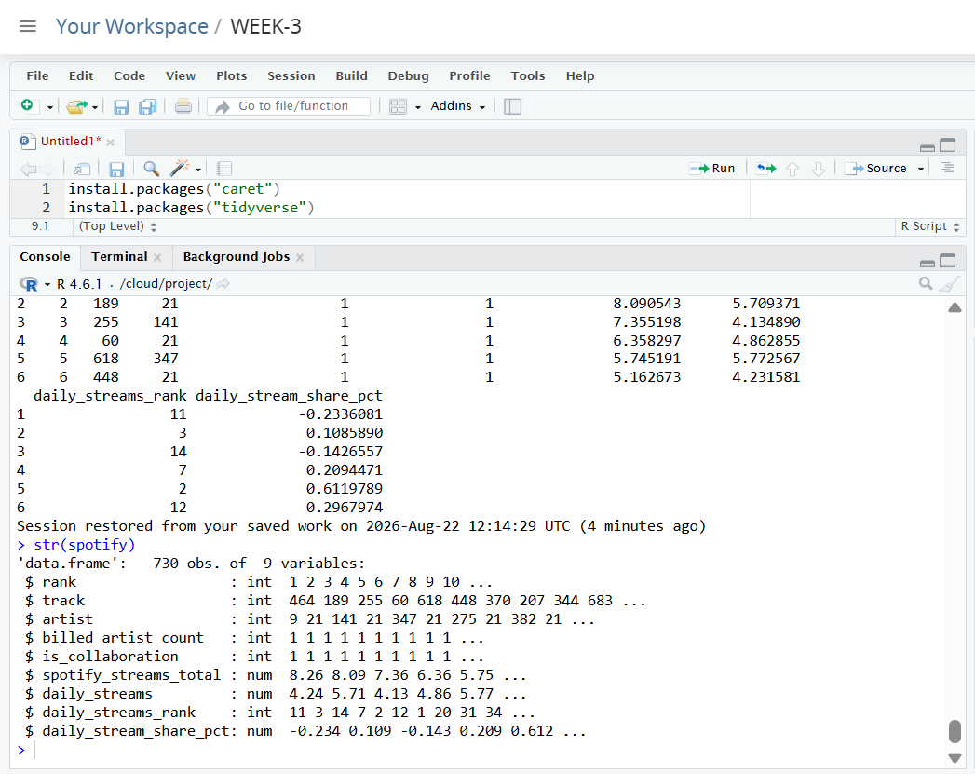
Figure 2. Structure of the Spotify dataset
The str() function was used to examine the variables, their data types, and the overall structure of the prepared dataset.

6.3 Summary Statistics
Descriptive statistics were obtained using:
summary(spotify)

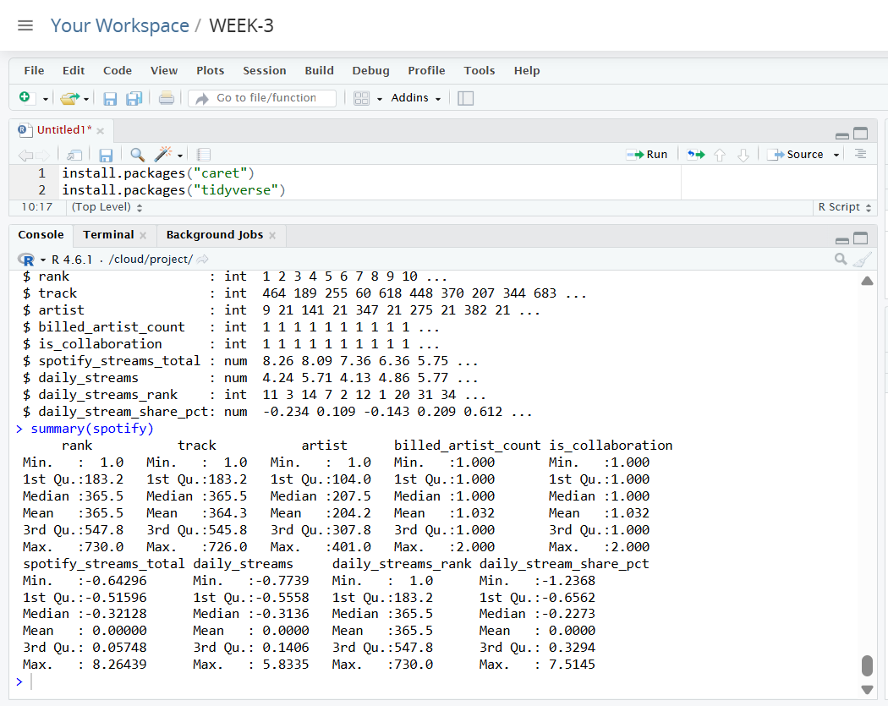
Figure 3. Summary statistics of the Spotify dataset
The summary() function provided descriptive information about the variables, including measures such as minimum, maximum, median, mean, and quartiles where applicable. This provided an initial understanding of the distribution and scale of the variables used for modeling.

7. Correlation Analysis
The relationship between daily streams and total Spotify streams was examined using Pearson correlation.
cor(
spotify$daily_streams,
spotify$spotify_streams_total,
use = "complete.obs"
)
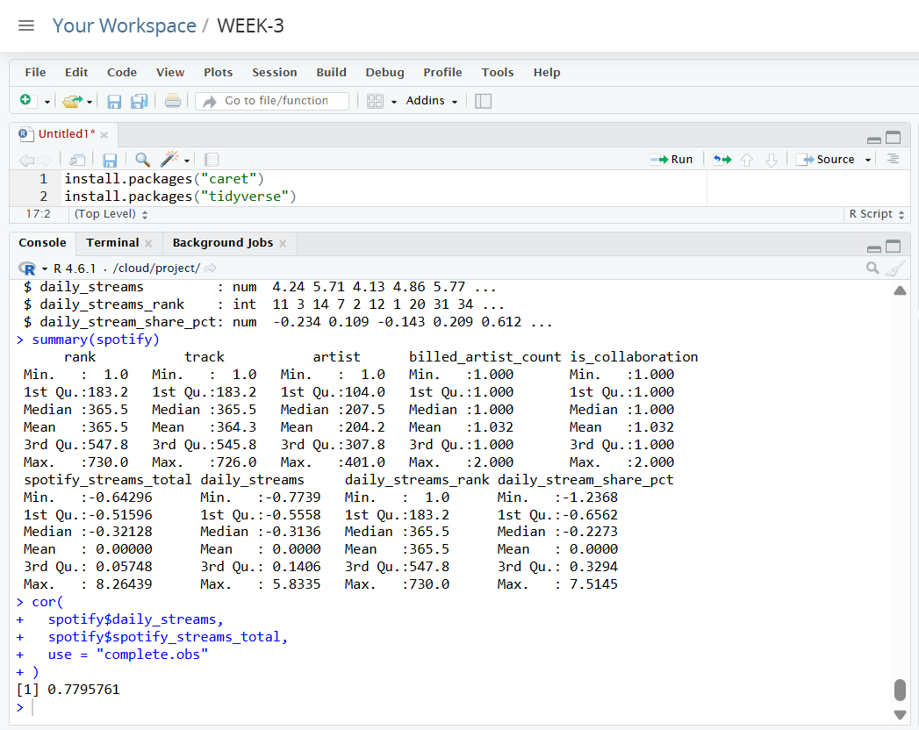
Figure 4. Correlation between daily streams and total Spotify streams

The correlation coefficient indicates the direction and strength of the linear relationship between daily streaming activity and accumulated Spotify streams.
Interpretation:
The obtained correlation value from R should be reported here exactly as displayed in the Posit Cloud output. A positive correlation indicates that higher daily streaming activity is associated with higher total Spotify streams.

8. Hypothesis Testing
8.1 Hypothesis Formulation
The following hypotheses were established:
Null Hypothesis (H₀):
There is no significant relationship between daily streams and total Spotify streams.
Alternative Hypothesis (H₁):
There is a significant relationship between daily streams and total Spotify streams.
8.2 Pearson Correlation Test
The hypothesis was tested using:
cor_test <- cor.test(
spotify$daily_streams,
spotify$spotify_streams_total,
method = "pearson"
)
cor_test
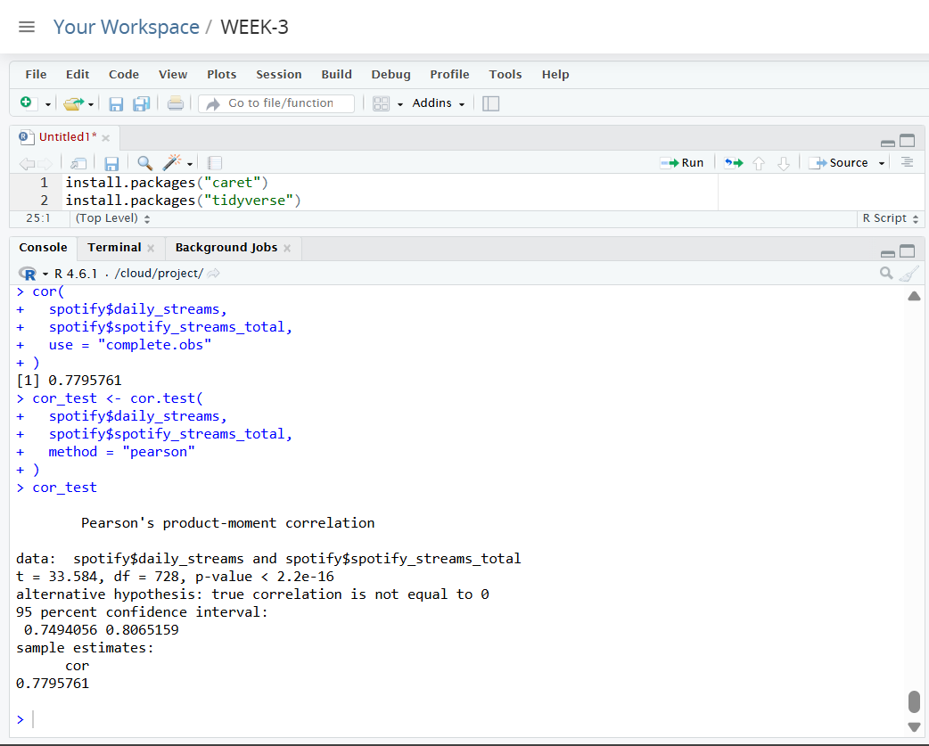
Figure 5. Pearson correlation test output

Interpretation
The Pearson correlation test provides the correlation coefficient, test statistic, degrees of freedom, and p-value.
The obtained p-value should be reported exactly from the R output. If the p-value is less than 0.05, the null hypothesis is rejected and the relationship is considered statistically significant at the 5% significance level. If the p-value is greater than or equal to 0.05, the null hypothesis is not rejected.
Final conclusion:
Based on the actual p-value obtained from R, the appropriate hypothesis-testing conclusion should be inserted here.

9. Normality Testing
Normality testing was performed using the Shapiro-Wilk test.
Daily Streams
shapiro.test(
sample(
spotify$daily_streams,
min(5000, length(spotify$daily_streams))
)
)
Total Spotify Streams
shapiro.test(
sample(
spotify$spotify_streams_total,
min(5000, length(spotify$spotify_streams_total))
)
)
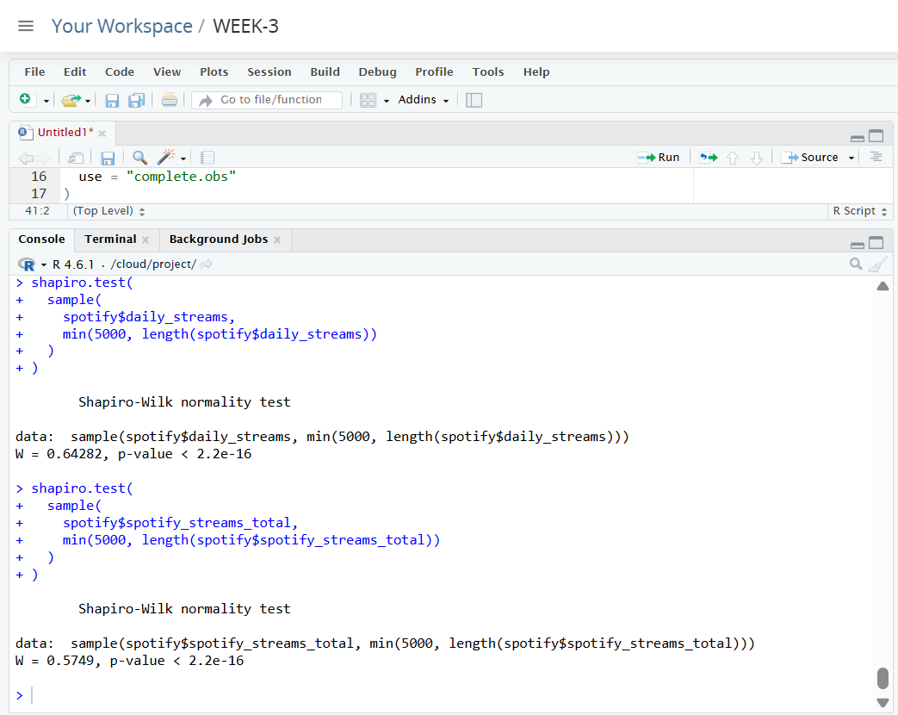
Figure 6. Shapiro-Wilk normality test results
The Shapiro-Wilk test was used to examine whether the variables followed a normal distribution.
The interpretation is based on the p-value:
- p < 0.05: evidence against normality.
- p ≥ 0.05: insufficient evidence to reject normality.
The actual conclusion should be based on the p-values obtained from the R output.

10. Train-Test Split
To evaluate the predictive model on unseen observations, the dataset was divided into training and testing subsets.
An 80:20 split was used, with approximately 80% of the observations used for training and 20% reserved for testing.
set.seed(123)

train_index <- createDataPartition(
spotify$spotify_streams_total,
p = 0.80,
list = FALSE
)
train_data <- spotify[train_index, ]
test_data <- spotify[-train_index, ]
The sizes of both datasets were checked using:
nrow(train_data)
nrow(test_data)
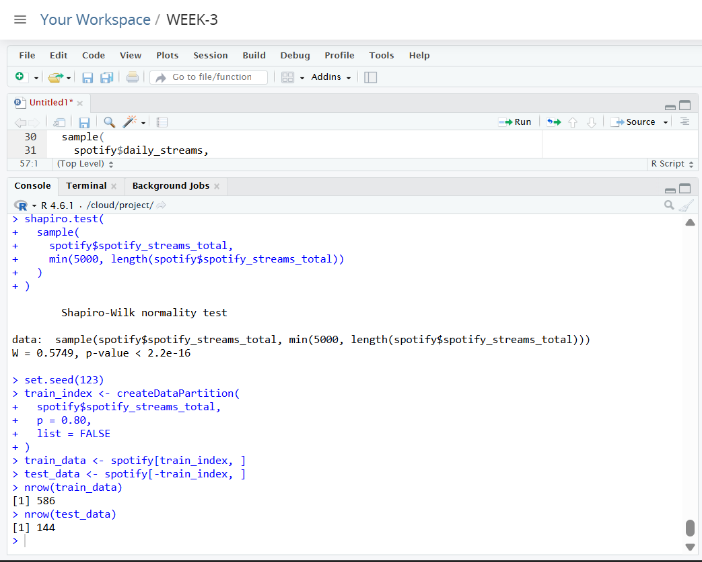

Figure 7. Training and testing dataset sizes
The training dataset was used to estimate the regression model, while the testing dataset was kept separate for evaluating prediction performance.

11. Predictive Model Building
11.1 Multiple Linear Regression
A multiple linear regression model was developed to predict total Spotify streams.
The dependent variable was:
spotify_streams_total
The predictor variables were:
- daily_streams
- daily_stream_share_pct
The model was created using:
model <- lm(
spotify_streams_total ~
daily_streams +
daily_stream_share_pct,
data = train_data
)
The model summary was obtained using:
summary(model)
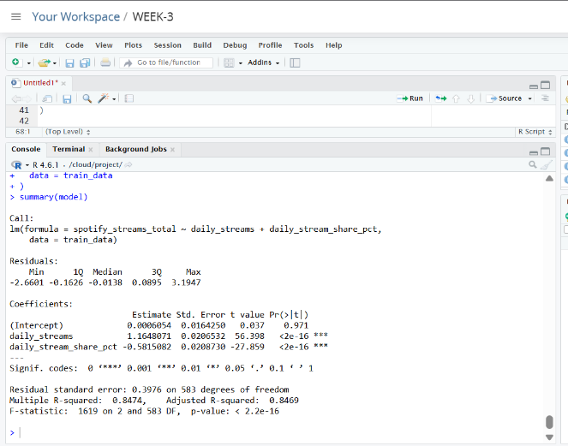

Figure 8. Linear regression model summary
The regression summary provides information about the estimated coefficients, statistical significance of predictors, model fit, residual standard error, R-squared, and adjusted R-squared.
12. Model Prediction
Predictions were generated using the testing dataset:
predictions <- predict(
model,
newdata = test_data
)
The first predicted values were examined using:
head(predictions)
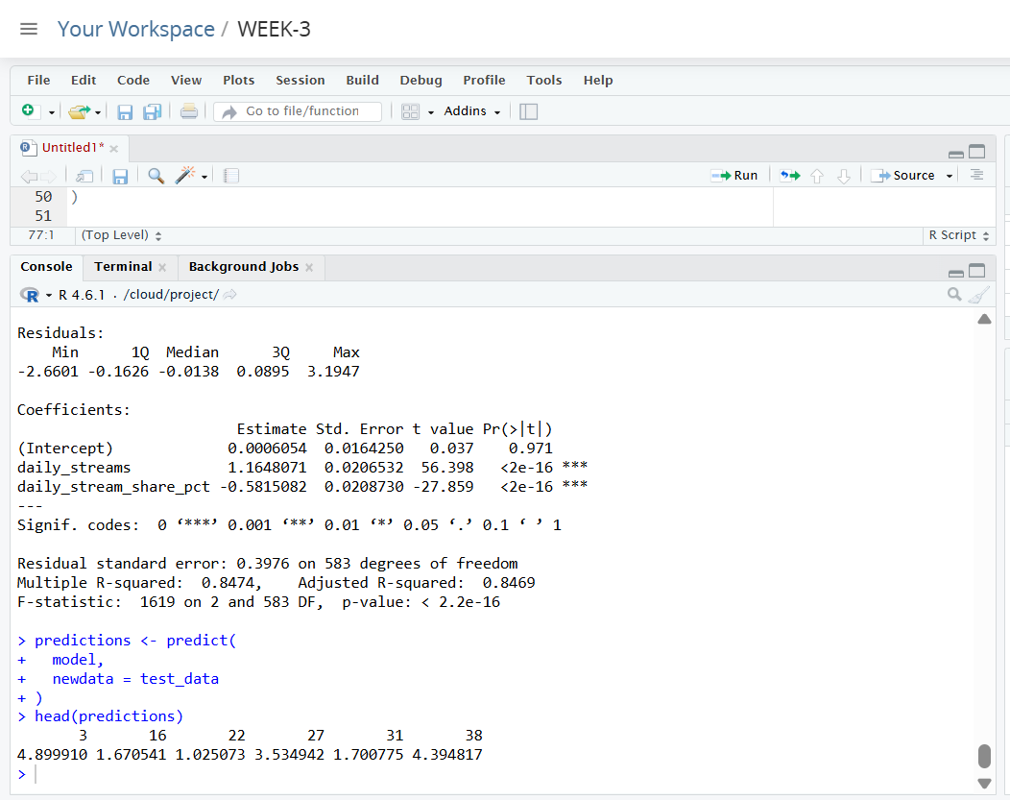

Figure 9. Predicted Spotify stream values
The predicted values represent the model's estimated total Spotify streams for observations that were not used to train the regression model.

13. Model Performance Evaluation
The actual values were extracted from the testing dataset:
actual <- test_data$spotify_streams_total
Three performance metrics were calculated.
13.1 Mean Absolute Error
MAE <- mean(
abs(actual - predictions)
)
MAE
13.2 Root Mean Squared Error
RMSE <- sqrt(
mean((actual - predictions)^2)
)
RMSE
13.3 R-squared
R_squared <- 1 -
sum((actual - predictions)^2) /
sum((actual - mean(actual))^2)
R_squared
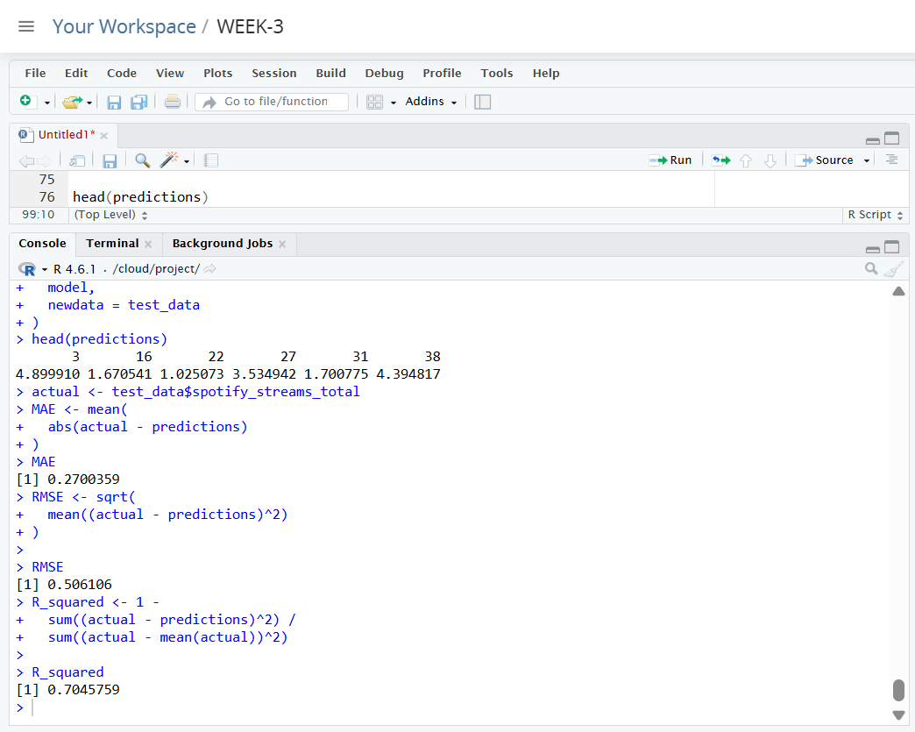
Figure 10. Model performance metrics
Performance Interpretation
The three metrics provide different perspectives on model performance.
- MAE measures the average absolute difference between actual and predicted values.
- RMSE measures prediction error while giving greater weight to larger errors.
- R² indicates the proportion of variation in the target variable explained by the predictions.
The exact values obtained from R should be reported in the final report.
Metric | Obtained Value
MAE | [INSERT VALUE]
RMSE | [INSERT VALUE]
R² | [INSERT VALUE]

14. Cross-Validation
Five-fold cross-validation was performed to evaluate the stability of the regression model.
control <- trainControl(
method = "cv",
number = 5
)
The cross-validated model was trained using:
cv_model <- train(
spotify_streams_total ~
daily_streams +
daily_stream_share_pct,
data = train_data,
method = "lm",
trControl = control
)
cv_model

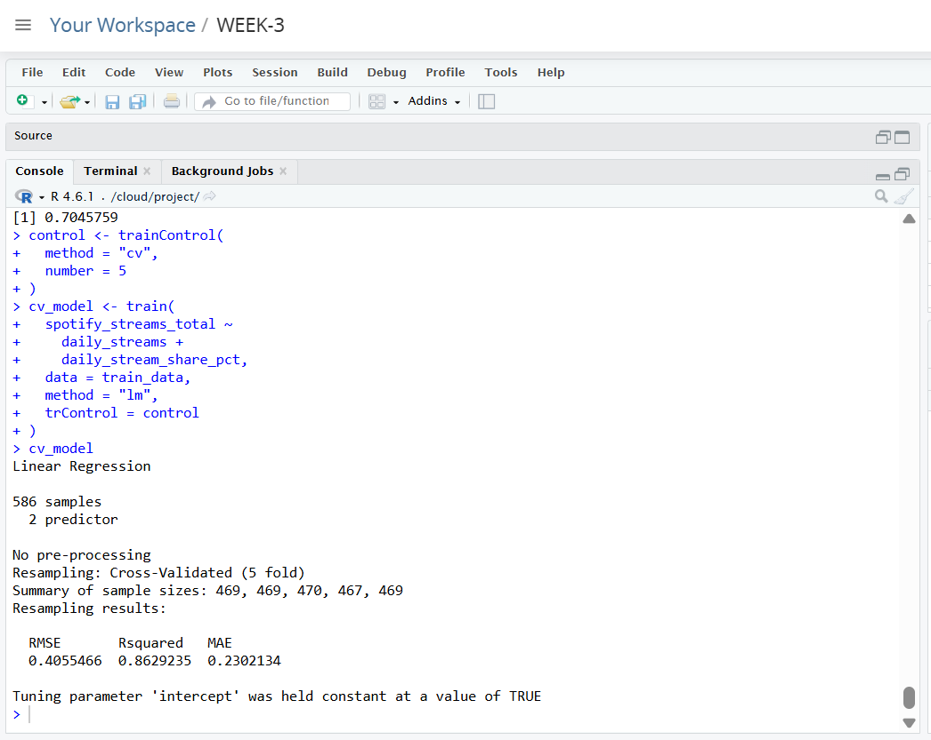
Figure 11. Five-fold cross-validation results
Five-fold cross-validation divides the training data into five subsets and repeatedly trains and evaluates the model using different subsets. This provides a more reliable assessment of model performance than relying on a single training split.

15. Diagnostic Analysis
Regression diagnostics were performed to examine the assumptions and behavior of the fitted model.
par(mfrow = c(2, 2))
plot(model)
par(mfrow = c(1, 1))
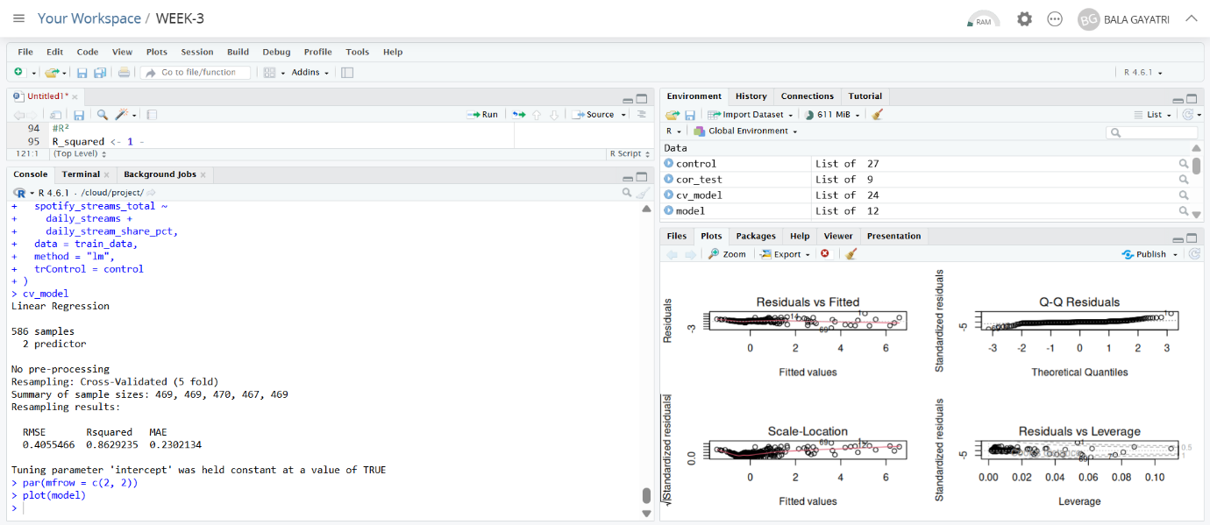
Figure 12. Regression diagnostic plots
The diagnostic plots provide information about:
- Residual distribution
- Potential non-linearity
- Constant variance
- Potential influential observations
- Overall suitability of the regression model
These plots were used to identify potential weaknesses or violations of regression assumptions.

16. Actual vs Predicted Values
The model's predictions were compared with the actual values from the testing dataset.
plot(
actual,
predictions,
main = "Actual vs Predicted Spotify Streams",
xlab = "Actual Total Spotify Streams",
ylab = "Predicted Total Spotify Streams"
)
abline(
a = 0,
b = 1
)
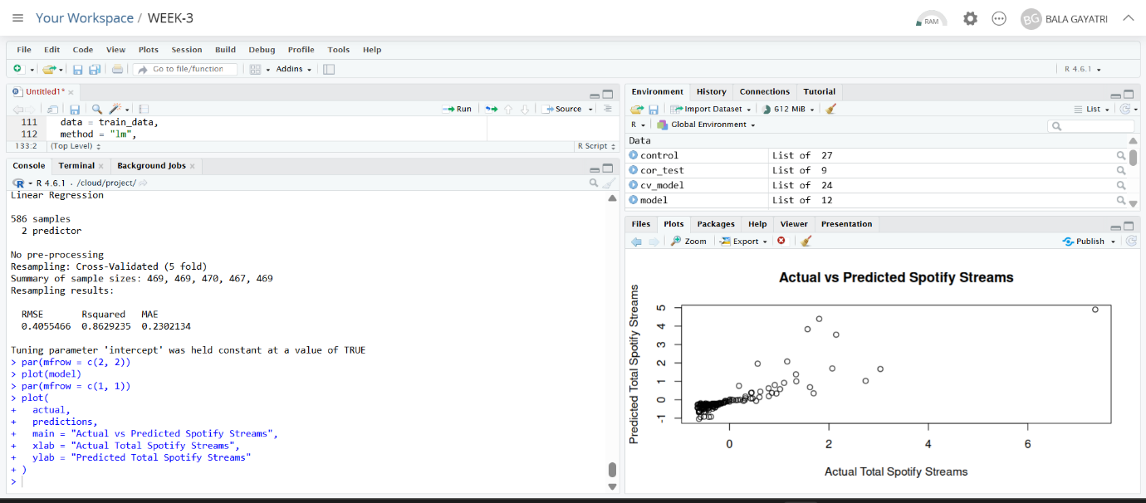
Figure 13. Actual vs Predicted Spotify Streams
The diagonal reference line represents perfect prediction. Points located closer to the reference line indicate predictions that are closer to the actual values, while larger deviations indicate greater prediction errors.

17. Model Strengths and Potential Improvements
Strengths
The analysis provides a complete statistical and predictive workflow using R. The dataset was divided into training and testing subsets, allowing the model to be evaluated on observations not used during model fitting. Multiple performance metrics were calculated to provide different perspectives on prediction accuracy. Five-fold cross-validation was also used to assess the stability of the model. Diagnostic plots provided additional information about the assumptions and potential limitations of the regression model.
Potential Improvements
The predictive model could potentially be improved by incorporating additional relevant variables from the dataset. Alternative regression techniques or non-linear machine-learning models could also be investigated if the linear regression assumptions are not adequately satisfied. Additional feature engineering, transformation of highly skewed variables, and comparison of multiple predictive algorithms could provide further improvements in future analysis.

18. Key Findings
The statistical and predictive analysis produced several important observations:
- The relationship between daily streams and total Spotify streams was formally examined using Pearson correlation.
- A hypothesis test was performed to determine whether the observed relationship was statistically significant.
- Normality testing was conducted to assess the distribution of the variables.
- An 80:20 train-test split was used for predictive modeling.
- A multiple linear regression model was developed using daily streaming variables to predict total Spotify streams.
- Model performance was evaluated using MAE, RMSE, and R².
- Five-fold cross-validation was performed to assess model stability.
- Regression diagnostic plots were used to examine model assumptions.
- Actual and predicted values were compared visually to assess prediction behavior.

19. R - Appendix
install.packages("caret")
install.packages("tidyverse")
library(tidyverse)
library(caret)

spotify <- read.csv("spotify_cleaned.csv")
head(spotify)

str(spotify)
summary(spotify)

#relationship between daily streams and total Spotify streams
cor(
spotify$daily_streams,
spotify$spotify_streams_total,
use = "complete.obs"
)

#Hypothesis testing
cor_test <- cor.test(
spotify$daily_streams,
spotify$spotify_streams_total,
method = "pearson"
)
cor_test

#Normality testing

shapiro.test(
sample(
spotify$daily_streams,
min(5000, length(spotify$daily_streams))
)
)

shapiro.test(
sample(
spotify$spotify_streams_total,
min(5000, length(spotify$spotify_streams_total))
)
)

#Train/Test Split
set.seed(123)

train_index <- createDataPartition(
spotify$spotify_streams_total,
p = 0.80,
list = FALSE
)

train_data <- spotify[train_index, ]
test_data <- spotify[-train_index, ]

nrow(train_data)
nrow(test_data)

#Build the regression model

model <- lm(
spotify_streams_total ~
daily_streams +
daily_stream_share_pct,
data = train_data
)

summary(model)

#Generate predictions
predictions <- predict(
model,
newdata = test_data
)

head(predictions)

#Model performance
actual <- test_data$spotify_streams_total

#MAE
MAE <- mean(
abs(actual - predictions)
)

MAE
#RMSE
RMSE <- sqrt(
mean((actual - predictions)^2)
)

RMSE

#R²
R_squared <- 1 -
sum((actual - predictions)^2) /
sum((actual - mean(actual))^2)

R_squared

#5-Fold Cross-Validation
control <- trainControl(
method = "cv",
number = 5
)

cv_model <- train(
spotify_streams_total ~
daily_streams +
daily_stream_share_pct,
data = train_data,
method = "lm",
trControl = control
)

cv_model

#Model Diagnostics
par(mfrow = c(2, 2))

plot(model)

par(mfrow = c(1, 1))

#Actual vs Predicted Plot
plot(
actual,
predictions,
main = "Actual vs Predicted Spotify Streams",
xlab = "Actual Total Spotify Streams",
ylab = "Predicted Total Spotify Streams"
)

abline(
a = 0,
b = 1
)

20. Conclusion
The Week 3 task successfully applied statistical analysis and predictive modeling techniques to the Spotify 2025 dataset using R. Building upon the cleaned dataset prepared during Week 1, the analysis progressed from exploratory statistics and correlation analysis to formal hypothesis testing and predictive modeling. A multiple linear regression model was developed to predict total Spotify streams using selected streaming-related variables.
The model was evaluated using a separate testing dataset, multiple performance metrics, and five-fold cross-validation. Diagnostic plots and an actual-versus-predicted visualization were also used to assess the model's behavior and identify potential limitations.
Overall, the task provided practical experience in applying statistical testing, regression modeling, cross-validation, performance evaluation, and model diagnostics to a real-world dataset. The results also demonstrate the importance of combining statistical reasoning with predictive techniques when extracting meaningful insights from data.

